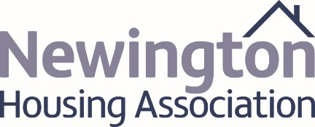

SEEKING NEW VOLUNTARY BOARD MEMBERS

Looking for a new challenge to share and develop your skills by leading a charity and growing Housing Association? For over 45 years Newington Housing Association has been working in North Belfast and currently manages approximately 750 homes. In recent years, the Association has completed substantial regeneration projects throughout North Belfast. The Association has played a key role in improving the built environment but also works, in partnership with others to build sustainable communities and improve the quality of life and increase opportunities for residents.

Board members undertake a vital role in meeting the challenges of governance and leadership in the Association and in respect to networking and representation, you will also play a role in influencing the development of housing policy and strategy in Northern Ireland.

We welcome applications from all sections and backgrounds of our community and from persons who can demonstrate knowledge, skills, and experience in one or more of the following areas:

- Property surveying, development, architecture,*
- Accountancy practice/senior finance/banking role*
- Corporate and Charity Governance*
- Law* (housing/construction/employment/contract)
- Public Sector procurement*
- Human Resources, Occupational health/therapy, Public Relations*
- Community Development
- Social Housing Management/Policy/Research
- Health & Safety in residential/public settings
- Audit, Compliance and Risk Management
- Organisational Development and Change Management
- Business Improvement and Customer Excellence
- Strategic Leadership & Policy development
- Equality, Diversity and Good Relations
(* denotes priority skills in bold - At shortlisting stage, preference will be given to those applicants demonstrating both significant recent experience and demonstratable knowledge in those areas).

Applicants should possess excellent communication, and interpersonal skills with proven ability to engage professionally, positively and constructively with people of all levels.

The average time commitment involves attending a minimum of 4 Board meetings, 4 Committee meetings and one Strategic Planning session per year, as well as ad hoc conferences, training and seminars. Induction, on-going support and a Governance Handbook and key organisational documents will be provided. All reasonable expenses incurred as part of the role will be reimbursed.

An Application Form, role description and additional information available in the Recruitment Pack.

To request a pack please contact: Anthony Kerr, 300 Limestone Road, Belfast BT15 3AR.
Email a.kerr@newingtonha.co.uk Tel: 02890 744055

Closing date for receipt of applications is Friday 15th July 2022

